4403-2 Ave, Edson, AB, T7E 1C1
(780)723-3354 Fax (780)723-5992
Emergencies (780)723-3355
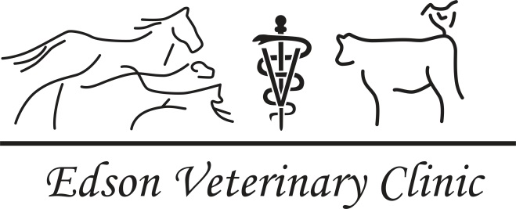

Dr. Anne Rogers Dr. Taylor Sobchuk Dr. Eiry Spence
Equine Owner/Producer Questionnaire
In order to provide you with the best advice and treatment for your horses, we are asking our equine clients to fill out this questionnaire. There are many different vaccination and deworming protocols used by clients and each horse is unique in its needs based on its profession, age, past experiences, etc. Our goal is to work with you to make individual protocols that work for your operation. Please fill in the questionnaire as completely as you can, and add any additional information you think would be important.
Farm Name (if applicable): _____________________________________________________________
Client Last Name: _________________________________
Client First Name(s): _________________________________
Contact Information: _______________________________________________
_______________________________________________
_______________________________________________
Email: _________________________________________________________________________________
Tell us about your horses…
I have… <3 horses >3 horses >10 horses
If <5 horses…
Name | Breed | Age | Gender | Notable Conditions

If >5 horses…
Breed(s): _________________________________________________________________
Age range: _________________________________________________________________
Do any of your horses have notable conditions? YES / NO
Please explain: ________________________________________________________________
_____________________________________________________________________________
Are any of your horses on any medications? YES / NO
Horse: ______________________ Medication: __________________________________
Horse: ______________________ Medication: __________________________________
_________________________________________________________________________________________________________________________________
What do you do with your horses?
__________________________________________________________________________________________________________________________________________________________________________________________________________________________________
BREEDING (If you breed)
Do you breed your horses? YES / NO
How did you breed the mares? Live Cover Artificial Insemination Other
How many foals did you have this year? ___________________
Were there any issues with any foaling(s) or foals/mares? YES / NO
If yes, please provide some information: _______________________________________________
_________________________________________________________________________________
Do you give your foals any injections at birth? YES / NO
If yes, which ones? ___________________________________________________________
Do you check for pregnancy on your horses? YES / NO
If yes, when do you check for pregnancy? _______________________________________

VACCINE PROTOCOLS
Do you vaccinate your horses? YES / NO
What do you vaccinate for? Eastern Encephalitis Western Encephalitis Tetanus
West Nile Influenza Rhinovirus Strangles
Note
Typical 3 way vaccine has Eastern Encephalitis, Western Encephalitis and Tetanus
Vaccine such as Calvenza contains Influenza and Rhinovirus
When was the last time you vaccinated your horses?
___________________________________________________________________________________
Where do you typical obtain your vaccines from?
___________________________________________________________________________________
When do you first vaccinate your foals (if applicable)?
___________________________________________________________________________________
DEWORMING PROTOCOL
Which of the following products do you use to deworm your horse(s)?
Eqvalan Safeguard Quest Panacur Eqvalan Gold Quest Plus Other
When deworming, at what time(s) of the year do you treat with
____________________ (Insert product) Time of year: _________________________
____________________ (Insert product) Time of year: _________________________
____________________ (Insert product) Time of year: _________________________
Have you ever or do you perform fecals on your horses? YES / NO
GENERAL HERD HEALTH INFORMATION
Do you travel regularly with your horses? YES / NO
Do you show/compete with your horses? YES / NO
Does your farm implement any biosecurity protocols in regards to new additions or sick animals? (E.g. Do you have an isolation area, barn/stalls, dry pen?)
_______________________________________________________________________________________________________________________________________________________________________________________________________________
Do you set protocols for treating common illnesses, such as heaves, wounds, colic, etc? YES / NO
If no, are you interested in protocols that could be provided for you? YES / NO
Do you use a salt block? YES / NO
Do you feed mineral? YES / NO
If yes, which types and who manufactures it? _______________________________________
_______________________________________
How do you provide water to your horses? Trough Automatic Waterer
Dugout Flowing water
Do your horses have access to water in the winter? YES / NO
Are your horses pastured in the summer? YES / NO
If no, please give feeding details: ______________________________________________________
_________________________________________________________________________________
Do you provide your horses with any grain/feed/supplements? Which types/brands?
__________________________________________________________________________________________________________________________________________________________________________________________________________________________________

Thank you for taking the time to fill out this questionnaire. The answers you have provided will help us better help you and your production.

